Rectangular Decomposition

Definition
# Source: AI Source: Provided by: [Data Path: Persons Table -> ID Column: 1, Name_En Column: Motasem Essam] -> From: [ChatGPT] on [7/25/2026]
Rectangular Decomposition is a type of geometric figure decomposition in which a complex geometric figure is divided into two or more rectangles to simplify its analysis, measurement, or construction.
The rectangles may have equal or unequal dimensions. They can be used to calculate the total area of an irregular rectilinear figure, determine missing dimensions, or break a complicated shape into simpler parts.
Simple definition: Rectangular decomposition is dividing a larger or more complex shape into rectangles whose areas can be calculated separately.
Examples include:
- Dividing an L-shaped region into two rectangles.
- Dividing a T-shaped figure into rectangles.
- Decomposing a stepped polygon into several rectangles.
- Dividing a large rectangle into smaller rectangles.

Main Classification
# Source: AI Source: Provided by: [Data Path: Persons Table -> ID Column: 1, Name_En Column: Motasem Essam] -> From: [ChatGPT] on [7/25/2026]
The following is a practical classification, not a universally standardized mathematical taxonomy. The types can overlap.

1. L-Shaped Rectangular Decomposition
# Source: AI Source: Provided by: [Data Path: Persons Table -> ID Column: 1, Name_En Column: Motasem Essam] -> From: [ChatGPT] on [7/25/2026]
An L-shaped region is divided into two or more rectangles.
Example: A large rectangle with one corner removed, leaving an L-shaped region.
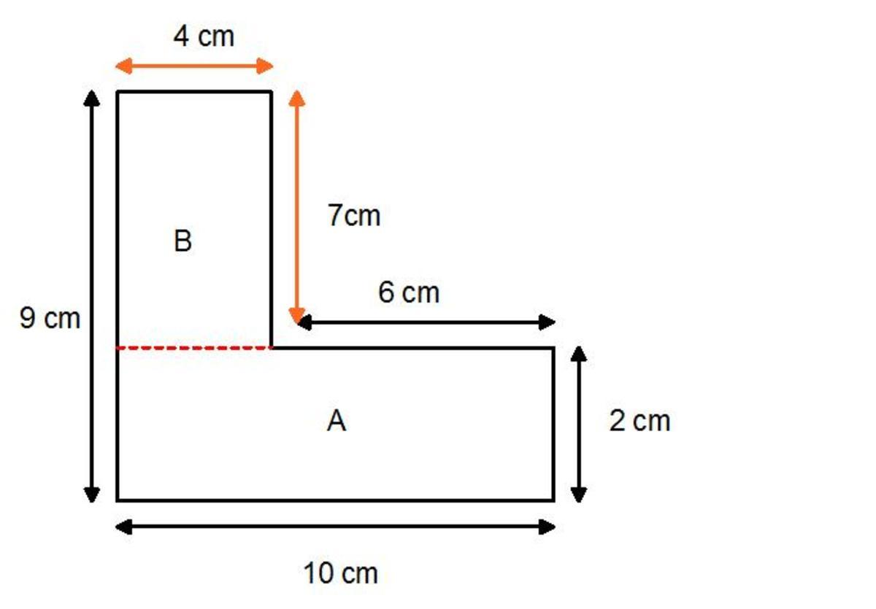
Detailed Explanation and Examples
Definition: An L-shaped region is divided into two or more non-overlapping rectangles.
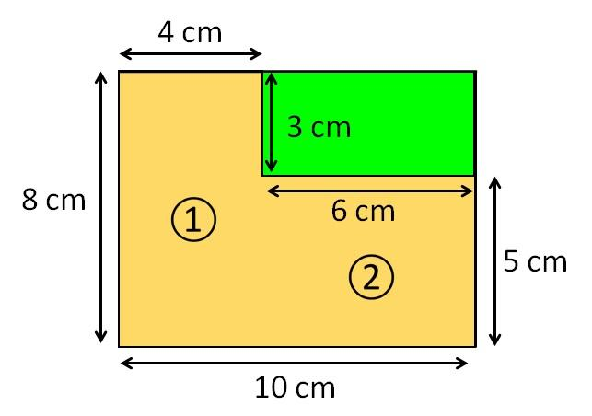
Example: Consider an L-shaped region formed from a $10×8$ outer rectangle with a $4×5$ rectangular corner removed.
Outer rectangle area:
$$A_{1}=10\left(8\right)=80$$
Removed rectangle area:
$$A_{2}=4\left(5\right)=20$$
Therefore, the L-shaped region has area:
$$\boxed{A=80-20=60}$$
Alternatively, the same region can be divided into two non-overlapping rectangles with dimensions $6×8$ and $4×3$:
$$A=6\left(8\right)+4\left(3\right)=48+12$$
$$\boxed{A=60}$$
Both methods give the same area.

2. T-Shaped Rectangular Decomposition
# Source: AI Source: Provided by: [Data Path: Persons Table -> ID Column: 1, Name_En Column: Motasem Essam] -> From: [ChatGPT] on [7/25/2026]
A T-shaped figure is divided into rectangular regions representing its top bar and stem.
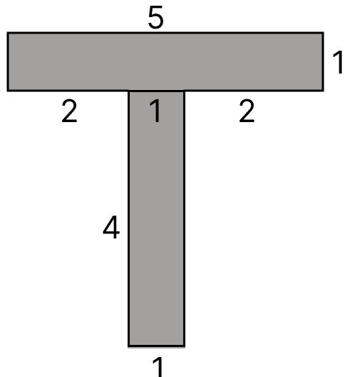
Detailed Explanation and Examples
Definition: A T-shaped region is divided into rectangles representing its horizontal bar and vertical stem.
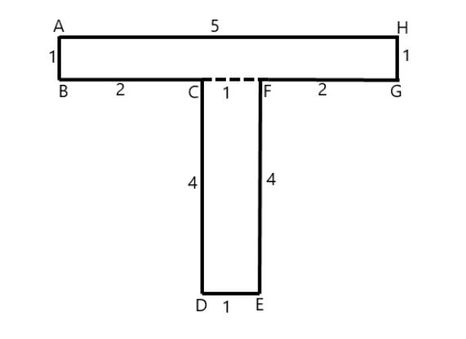
Example: A T-shaped region consists of:
- A top rectangle measuring $12×3$.
- A stem below it measuring $4×5$.
The rectangles meet along an edge without overlapping interiors.
Top rectangle:
$$A_{1}=12\left(3\right)=36$$
Stem:
$$A_{2}=4\left(5\right)=20$$
Total area:
$$\boxed{A=36+20=56}$$

3. Stepped-Shape Rectangular Decomposition
# Source: AI Source: Provided by: [Data Path: Persons Table -> ID Column: 1, Name_En Column: Motasem Essam] -> From: [ChatGPT] on [7/25/2026]
A staircase-like or stepped polygon is divided into rectangles according to its changing widths or heights.
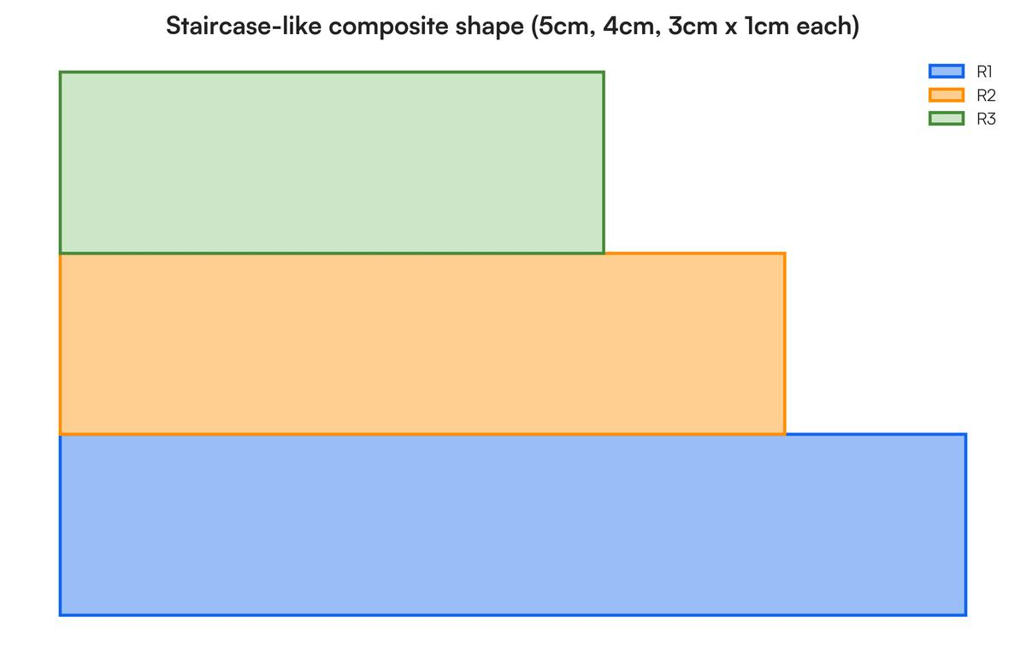
Detailed Explanation and Examples
Definition: A staircase-like region is divided into rectangles corresponding to its different steps.
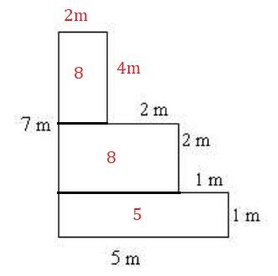
Example: A stepped region is divided into three horizontal rectangles with dimensions $8×2$, $6×2$, and $4×2$.
Their areas are:
$$A_{1}=8\left(2\right)=16$$
$$A_{2}=6\left(2\right)=12$$
$$A_{3}=4\left(2\right)=8$$
Thus,
$$\boxed{A=16+12+8=36}$$
This method is useful when a shape has several levels or steps.

4. Grid-Based Rectangular Decomposition
# Source: AI Source: Provided by: [Data Path: Persons Table -> ID Column: 1, Name_En Column: Motasem Essam] -> From: [ChatGPT] on [7/25/2026]
A rectangular region is divided into a grid of smaller rectangles.
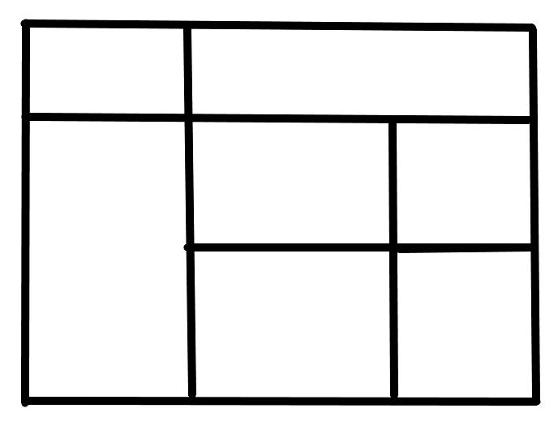
Detailed Explanation and Examples
Definition: A rectangular region is subdivided into smaller rectangles arranged in rows and columns.
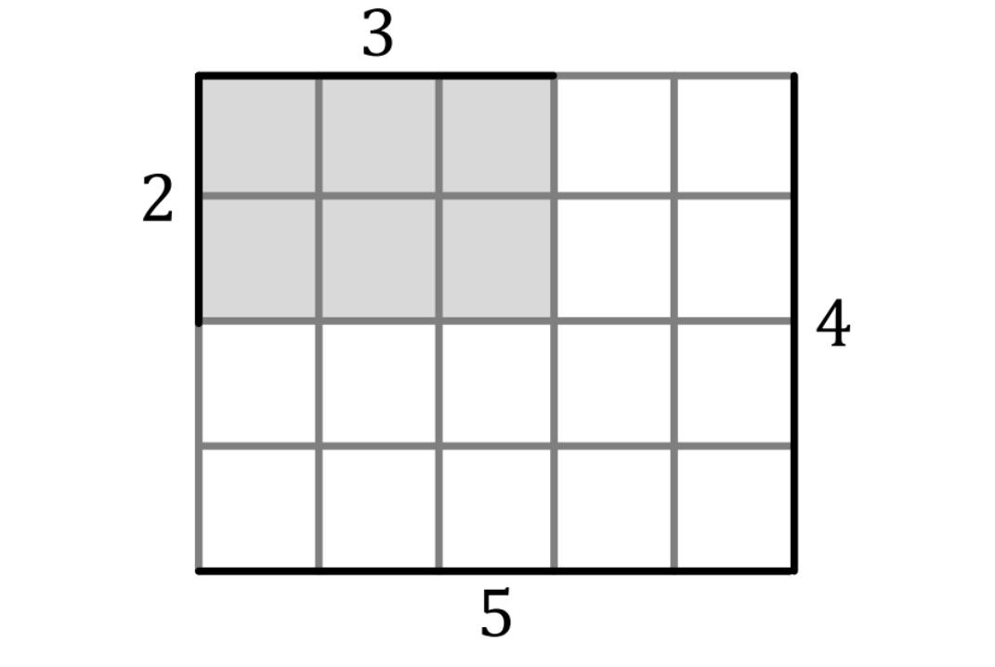
Example: A rectangle measuring $12×8$ is divided into six smaller rectangles using two vertical sections and one horizontal dividing line.
The total area of the original rectangle is:
$$A=12\left(8\right)=96$$
If the smaller rectangles have widths that sum to $12$ and heights that sum to $8$, their individual areas add to $96$.
For instance, with column widths $3,4,5$ and row heights $3,5$:
$$A=3\left(3\right)+4\left(3\right)+5\left(3\right)+3\left(5\right)+4\left(5\right)+5\left(5\right)$$
$$A=9+12+15+15+20+25$$
$$\boxed{A=96}$$

5. Irregular Rectilinear Decomposition
# Source: AI Source: Provided by: [Data Path: Persons Table -> ID Column: 1, Name_En Column: Motasem Essam] -> From: [ChatGPT] on [7/25/2026]
An irregular polygon with horizontal and vertical edges is partitioned into rectangles.
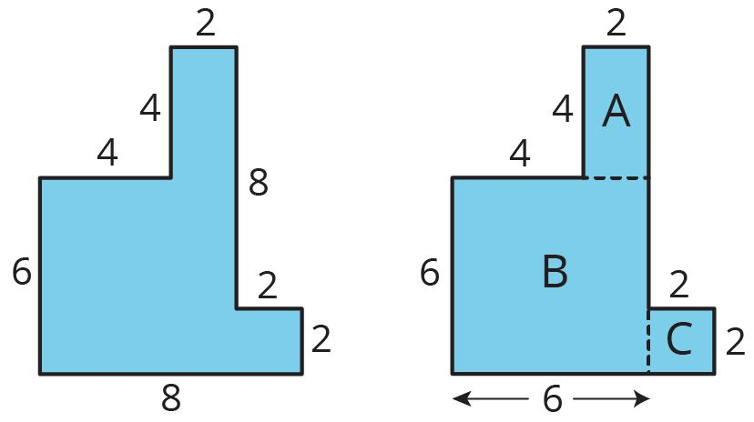
Detailed Explanation and Examples
Definition: A rectilinear polygon with horizontal and vertical edges is divided into rectangles even when its overall shape is irregular.
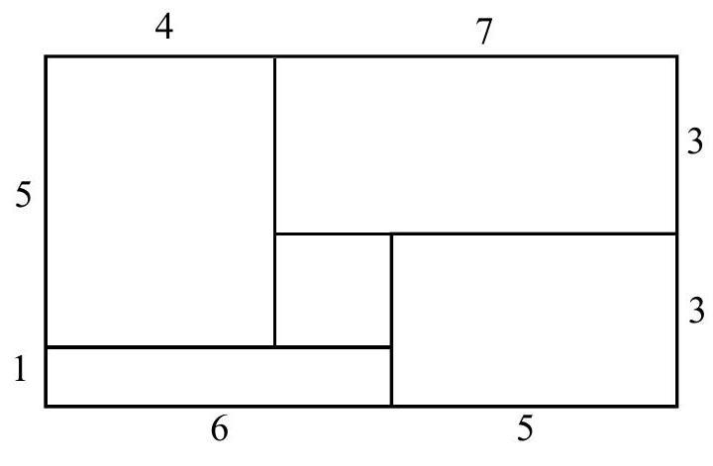
Example: An irregular rectilinear region can be divided into three rectangles with areas $18$, $24$, and $10$ square units.
The total area is:
$$A=A_{1}+A_{2}+A_{3}$$
$$\boxed{A=18+24+10=52}$$
The dimensions of the rectangles must be consistent with the original boundary for this to be a valid decomposition.

6. Strip-Based Rectangular Decomposition
# Source: AI Source: Provided by: [Data Path: Persons Table -> ID Column: 1, Name_En Column: Motasem Essam] -> From: [ChatGPT] on [7/25/2026]
A figure is divided into horizontal or vertical rectangular strips.
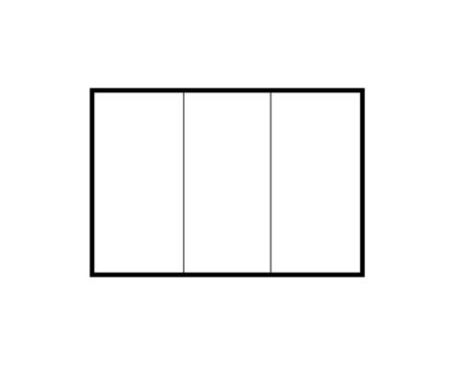
Detailed Explanation and Examples
Definition: A region is divided into horizontal or vertical strips, each of which is a rectangle.
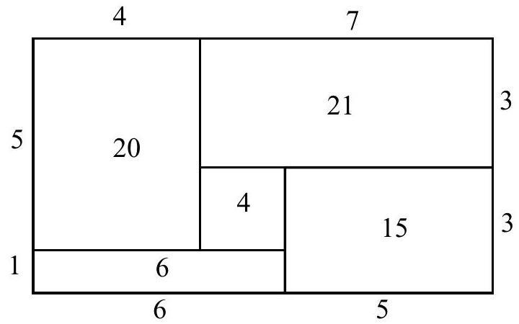
Example: A rectangular region has height $6$ units and is divided into four vertical strips of widths $2,3,4,5$.
Their areas are:
$$A_{1}=2\left(6\right)=12$$
$$A_{2}=3\left(6\right)=18$$
$$A_{3}=4\left(6\right)=24$$
$$A_{4}=5\left(6\right)=30$$
Therefore,
$$\boxed{A=12+18+24+30=84}$$
The total width is $2+3+4+5=14$, so the original area is also $14\left(6\right)=84$.

7. Multi-Rectangle Decomposition
# Source: AI Source: Provided by: [Data Path: Persons Table -> ID Column: 1, Name_En Column: Motasem Essam] -> From: [ChatGPT] on [7/25/2026]
A complex figure is divided into three or more rectangles, often using a combination of horizontal and vertical cuts.
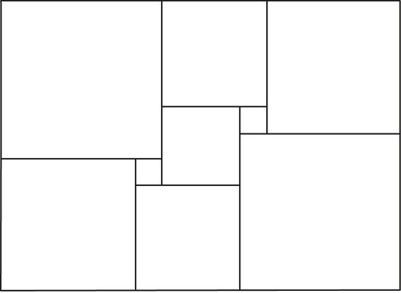
Detailed Explanation and Examples
Definition: A complex region is divided into several rectangles using multiple horizontal and vertical cuts.
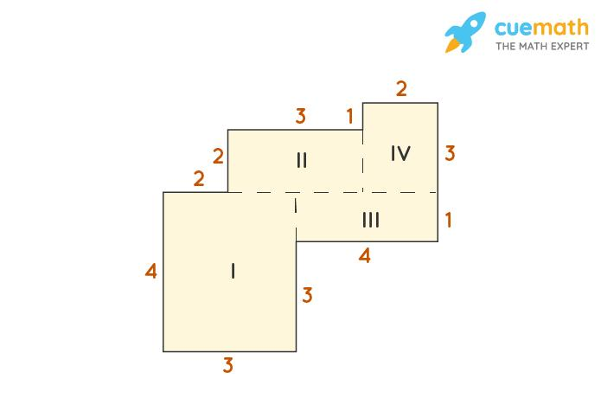
Example: A composite region is decomposed into four rectangles with dimensions $5×2$, $3×4$, $4×3$, and $2×2$.
Their areas are:
$$A_{1}=10, A_{2}=12, A_{3}=12, A_{4}=4$$
Total area:
$$\boxed{A=10+12+12+4=38}$$
This approach works when the rectangles cover the original region completely, with no gaps or overlapping interiors.

Important Formulas and Principles
# Source: AI Source: Provided by: [Data Path: Persons Table -> ID Column: 1, Name_En Column: Motasem Essam] -> From: [ChatGPT] on [7/25/2026]
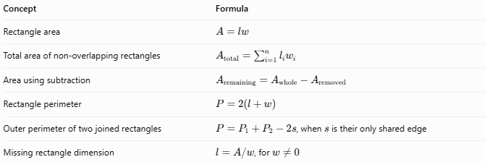
Concept | Formula
Rectangle area | $$A=lw$$
Total area of non-overlapping rectangles | $$A_{\text{total}}=\sum_{i=1}^{n}{l_{i}}w_{i}$$
Area using subtraction | $$A_{\text{remaining}}=A_{\text{whole}}-A_{\text{removed}}$$
Rectangle perimeter | $$P=2\left(l+w\right)$$
Outer perimeter of two joined rectangles | $P=P_{1}+P_{2}-2s$, when $s$ is their only shared edge
Missing rectangle dimension | $l=A/w$, for $w≠0$
Important distinction: Area is additive across a valid rectangular decomposition. Perimeter is not generally additive because shared internal edges are not part of the outer boundary.

Rectangular Decomposition vs. Related Concepts
# Source: AI Source: Provided by: [Data Path: Persons Table -> ID Column: 1, Name_En Column: Motasem Essam] -> From: [ChatGPT] on [7/25/2026]
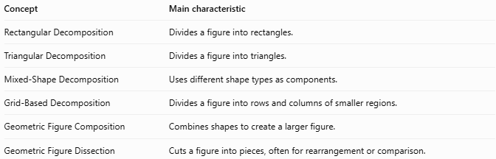
Concept | Main characteristic
Rectangular Decomposition | Divides a figure into rectangles.
Triangular Decomposition | Divides a figure into triangles.
Mixed-Shape Decomposition | Uses different shape types as components.
Grid-Based Decomposition | Divides a figure into rows and columns of smaller regions.
Geometric Figure Composition | Combines shapes to create a larger figure.
Geometric Figure Dissection | Cuts a figure into pieces, often for rearrangement or comparison.

Classification Summary
# Source: AI Source: Provided by: [Data Path: Persons Table -> ID Column: 1, Name_En Column: Motasem Essam] -> From: [ChatGPT] on [7/25/2026]
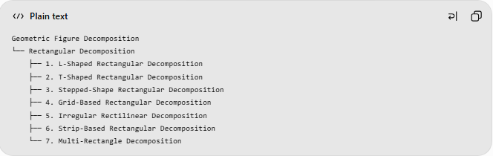
Geometric Figure Decomposition
└── Rectangular Decomposition
├── 1. L-Shaped Rectangular Decomposition
├── 2. T-Shaped Rectangular Decomposition
├── 3. Stepped-Shape Rectangular Decomposition
├── 4. Grid-Based Rectangular Decomposition
├── 5. Irregular Rectilinear Decomposition
├── 6. Strip-Based Rectangular Decomposition
└── 7. Multi-Rectangle Decomposition

Key Points
# Source: AI Source: Provided by: [Data Path: Persons Table -> ID Column: 1, Name_En Column: Motasem Essam] -> From: [ChatGPT] on [7/25/2026]
- Rectangular decomposition divides a larger or more complex region into rectangles.
- The component rectangles may have equal or unequal dimensions.
- The rectangles must cover the original region completely without gaps or overlapping interiors.
- The total area is the sum of the component areas.
- Subtraction can be used when the figure is easier to describe as a larger rectangle with a smaller region removed.
- The classification is practical and descriptive; some categories overlap.

Conclusion
# Source: AI Source: Provided by: [Data Path: Persons Table -> ID Column: 1, Name_En Column: Motasem Essam] -> From: [ChatGPT] on [7/25/2026]
Rectangular Decomposition is a useful geometric method for simplifying complex figures into rectangles whose areas are easy to calculate. It is particularly effective for L-shaped regions, T-shaped regions, stepped polygons, grids, and irregular rectilinear figures. Choosing a convenient partition makes calculations simpler while preserving the area and shape of the original region.

